Dr. Marcio de Queiroz
Louisiana State University
Department of Mechanical & Industrial Engineering
Innovation in Control & Robotics Engineering (iCORE) Laboratory
sampleresearcher@lsu.edu; (123) 456-7890

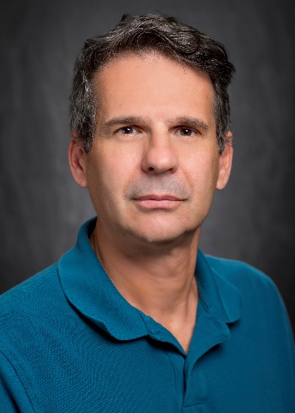

LaRC Research Topic:
Topic 1: Intelligent flight systems & trusted autonomy

Presentation title:
Decentralized formation control of teams of autonomous agents

Biography:
Marcio de Queiroz is a Professor of Mechanical Engineering at LSU. He’s the director of the iCORE Lab and coordinator for the Robotics Engineering minor. His research expertise is at the intersection of systems theory, control engineering, and robotics. Since 2011, Dr. Queiroz’s primary area of activity has been coordination control of multiple autonomous robotic vehicles. Such systems are intrinsic to missions that involve air traffic management, search and rescue, area coverage, perimeter protection, or co-transportation of large objects. The iCORE Lab is home to TIGER Square, an experimental testbed for multi-agent systems, which uses small, low-cost, custom-built, differential-drive robots as the mobile robot platform. The testbed can be operated in both centralized and decentralized modes of sensing, communication, and control.

